School of Computer Science and Artificial Intelligence

Lab Assignment 11.5

Name of Student : Devi Prasad Gunturu
Enrollment No. : 2303A51538
Batch No. : 22

Task Description #1 – Stack Implementation
Task: Use AI to generate a Stack class with push, pop, peek, and is_empty methods.
Sample Input Code: class Stack: pass
Expected Output:
• A functional stack implementation with all required methods and docstrings.
Prompt: The push method adds a new element to the top of the stack using the append() function. This operation takes constant time O(1).
The pop method removes and returns the top element of the stack. Before removing, it checks whether the stack is empty using the isEmpty method. If the stack is empty, it raises an IndexError to prevent stack underflow. This operation also runs in O(1) time.
The peek method returns the top element without removing it. It accesses the last element of the list using index [-1]. It also checks if the stack is empty before accessing the element. This operation takes O(1) time.
The isEmpty method checks whether the stack contains any elements. It returns True if the length of the list is zero; otherwise, it returns False. This operation runs in O(1) time.
All stack operations (push, pop, peek, isEmpty) execute in constant time O(1) because they only interact with the top element. The space complexity is O(n), where n is the number of elements stored in the stack.
Code:-
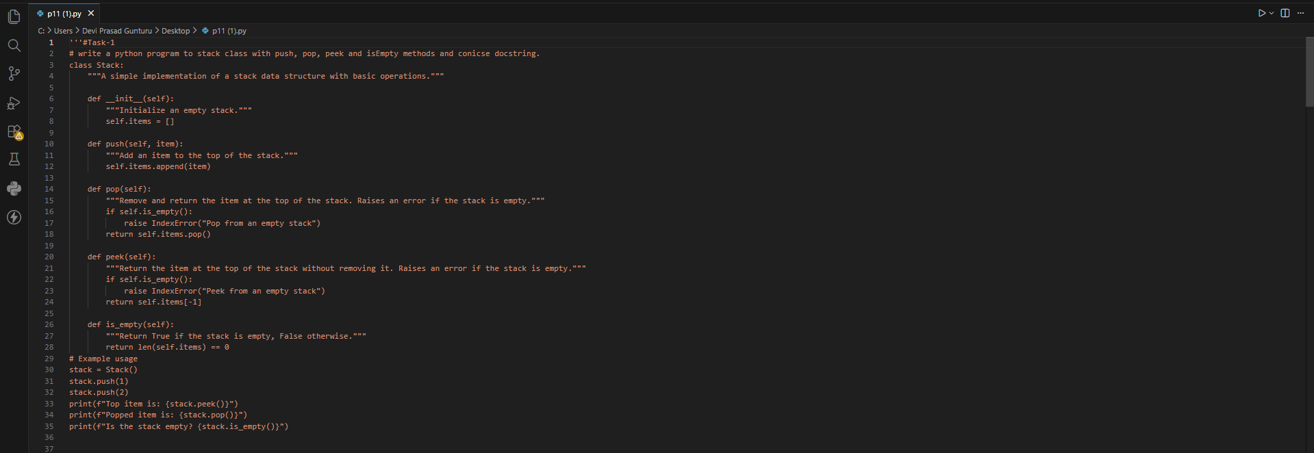
Output:-
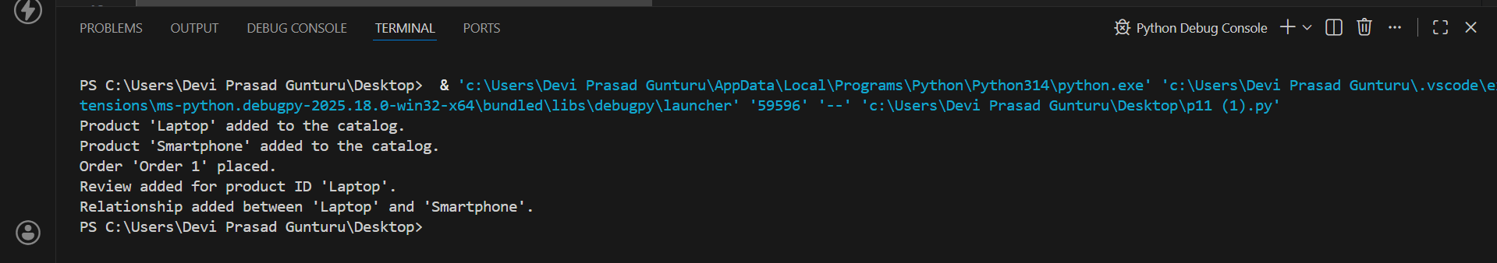
Justification:-
A stack is a Last-In-First-Out (LIFO) data structure, which is ideal for scenarios where the most recently added item needs to be accessed first. The push method allows adding items to the top of the stack, while the pop method removes and returns the top item. The peek method provides a way to view the top item without modifying the stack, and the isEmpty method checks if the stack has any items, ensuring that operations are performed safely.
Task Description #2 – Queue Implementation Task: Use AI to implement a Queue using Python lists. Sample Input Code: class Queue: pass
Expected Output:
• FIFO-based queue class with enqueue, dequeue, peek, and size methods.
Prompt:write a python program to implement a queue class with enqueue, dequeue, peek and isEmpty methods and concise docstring.
Code:-
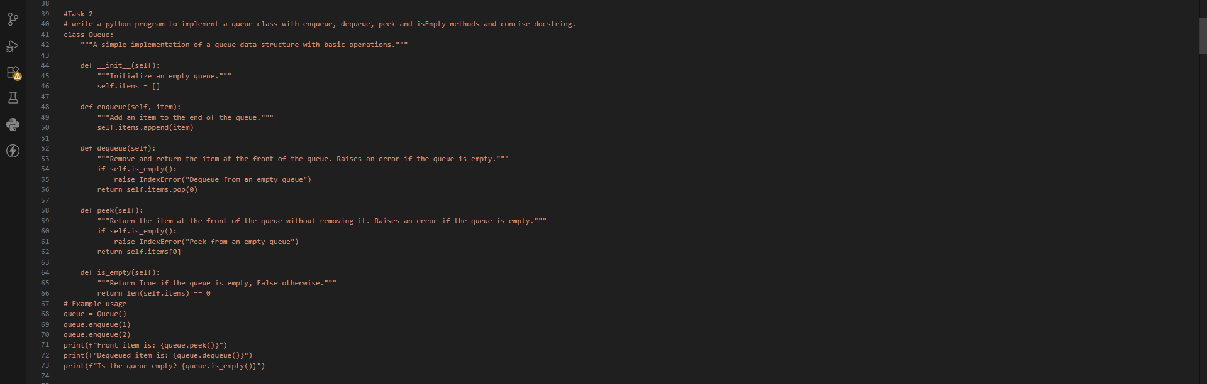
Output:-
Justification:-
A queue is suitable for managing vehicle wait times at traffic signals as it follows the FirstIn-First-Out (FIFO) principle, ensuring that vehicles are processed in the order they arrive at the signal.
Task Description #3 – Linked List
Task: Use AI to generate a Singly Linked List with insert and display methods.
Sample Input Code: class Node: pass class LinkedList: pass Expected Output:
• A working linked list implementation with clear method documentation.
Prompt:write a python program to implement a singly linked list class with insert, delete, search and display methods and concise docstring.
Code:-
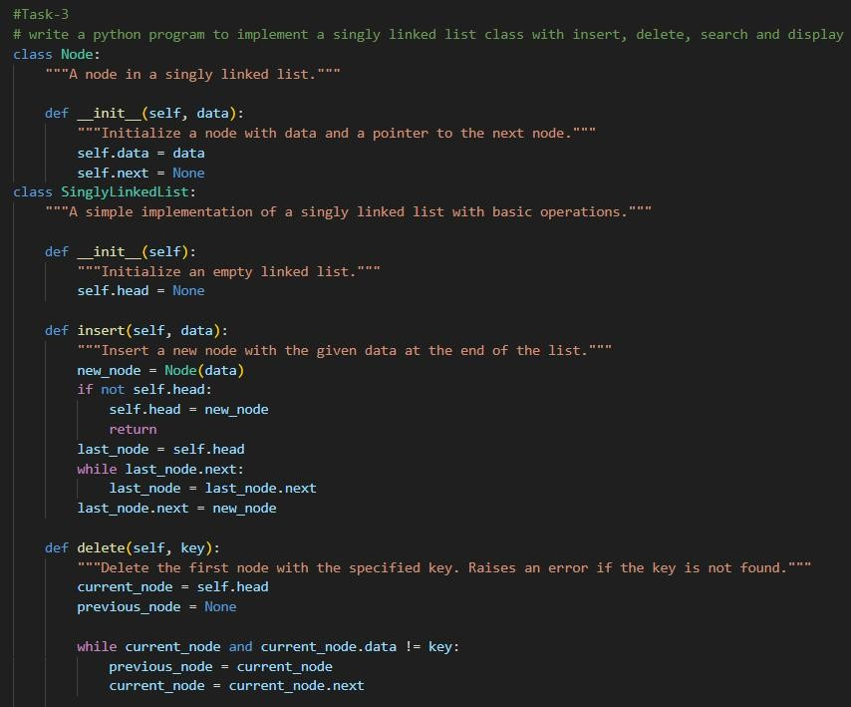
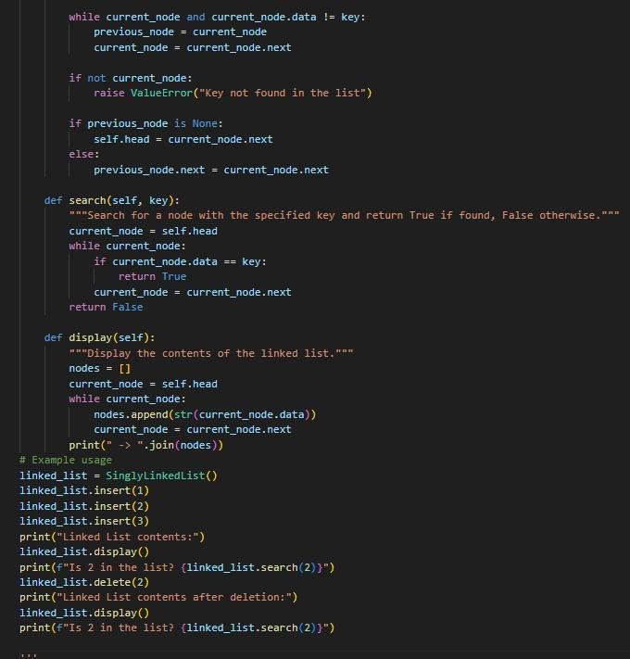
Output:-
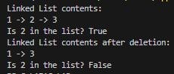
Justification:-
A singly linked list is suitable for this implementation as it allows for dynamic memory allocation and efficient insertion and deletion of nodes without the need for contiguous memory. The insert method adds new nodes at the end of the list, while the delete method removes nodes based on their value. The search method checks for the presence of a specific value, and the display method provides a visual representation of the list's contents. This structure is ideal for scenarios where the size of the list can change frequently and where efficient memory usage is a concern.
Task Description #4 – Hash Table
Task: Use AI to implement a hash table with basic insert, search, and delete methods. Sample Input Code: class HashTable: pass Expected Output:
• Collision handling using chaining, with well-commented methods.
Prompt:write a python program to implement a hash Table class with insert, delete, search and display methods and concise docstring.
Code:-
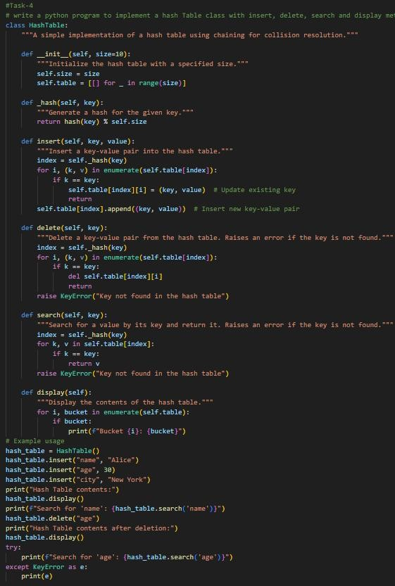
Output:-
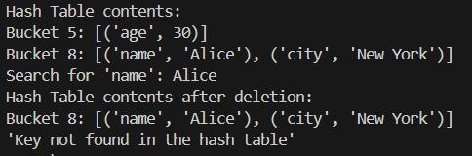
Justification:-
A hash table is efficient for storing and retrieving key-value pairs, making it ideal for applications like a hash table where fast access to data is crucial. The use of chaining allows for effective collision resolution, ensuring that the hash table can handle multiple entries with the same hash value without losing data integrity.
Task Description #5 – Graph Representation
Task: Use AI to implement a graph using an adjacency list.
Sample Input Code: class Graph: pass
Expected Output:
• Graph with methods to add vertices, add edges, and display connections.
Prompt:write a python program to implement a graph class using an adjacency list with add_vertex, add_edge, remove_vertex, remove_edge and display methods and concise docstring.
Code:-
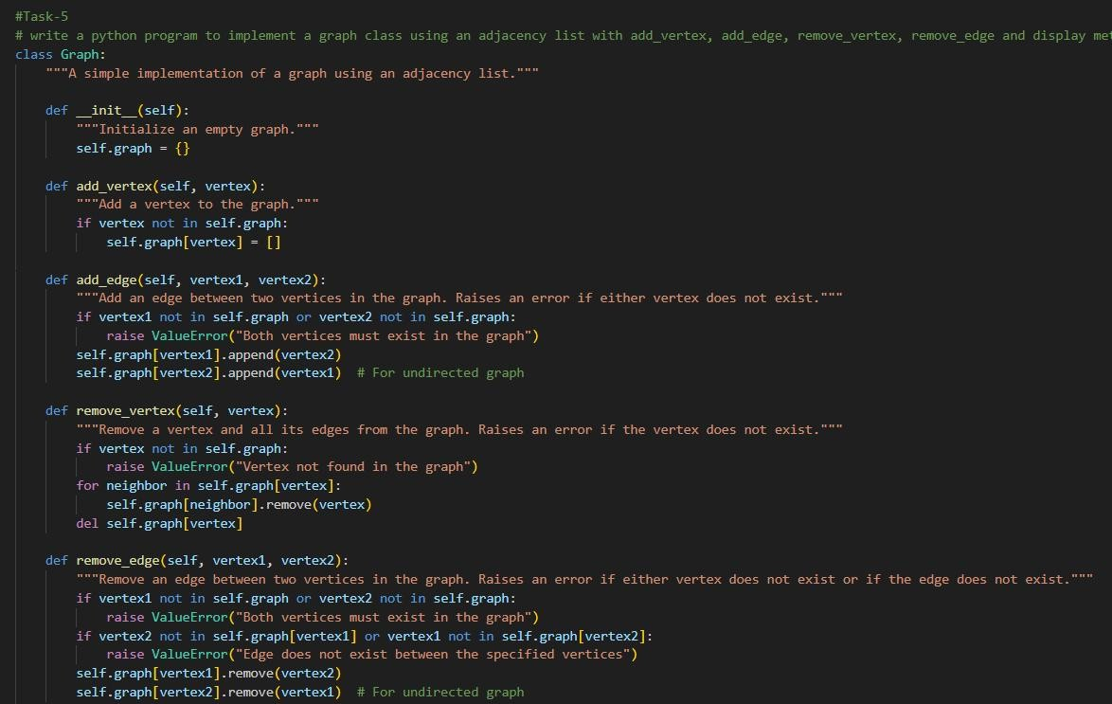
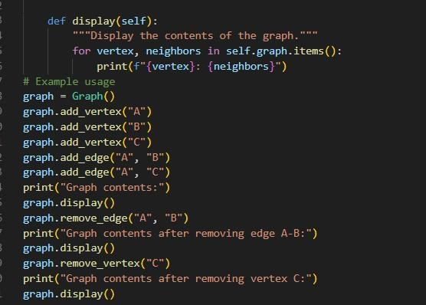
Output:-
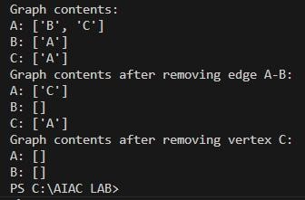
Justification:-
A graph is suitable for representing complex relationships between entities, such as social networks, transportation systems, or any scenario where connections between nodes are important. The adjacency list representation allows for efficient storage and traversal of the graph, making it ideal for scenarios with a large number of vertices and edges.
Task Description #6: Smart Hospital Management System – Data
Structure Selection
A hospital wants to develop a Smart Hospital Management System that handles:
- Patient Check-In System – Patients are registered and treated in order of arrival.
- Emergency Case Handling – Critical patients must be treated first.
- Medical Records Storage – Fast retrieval of patient details using ID.
- Doctor Appointment Scheduling – Appointments sorted by time.
- Hospital Room Navigation – Represent connections between wards and rooms.
Student Task
• For each feature, select the most appropriate data structure from the list below: o Stack o Queue o Priority Queue o Linked List o Binary Search Tree (BST)
o Graph o Hash Table o Deque
- Justify your choice in 2–3 sentences per feature.
- Implement one selected feature as a working Python program with AI-assisted code generation.
Expected Output:
- A table mapping feature → chosen data structure → justification.
- A functional Python program implementing the chosen feature with comments and docstrings.
Prompt:write a python program to implement a a Smart Hospital Management System. Choose the most suitable data structure (Stack, Queue, Priority Queue, Linked List, BST, Graph, Hash Table, or Deque) for each feature: patient check-in, emergency cases, medical records storage, appointment scheduling, and hospital navigation, and briefly explain why in 2–3 sentences each. Present your answers in a clear table. Then, implement one of the features as a working Python program with proper comments and docstrings.
Explanation:-
A Queue follows the First-In-First-Out (FIFO) principle, meaning the first patient who arrives is the first to be served. This ensures fairness and maintains proper order in the waiting area. It is simple and efficient for managing regular patient flow.
Feature: Emergency Cases
Data Structure: Priority Queue
Explanation:
A Priority Queue allows patients to be treated based on the severity of their condition rather than arrival time. Patients with more critical conditions are given higher priority and are treated first. This ensures life-threatening cases receive immediate attention.
Feature: Medical Records Storage
Data Structure: Hash Table
Explanation:
A Hash Table stores patient records using unique identifiers such as patient ID numbers. It provides very fast access, insertion, and retrieval of data. This is important in hospitals where quick access to medical information is essential.
Feature: Appointment Scheduling
Data Structure: Linked List
Explanation:
A Linked List is useful for managing appointments because it allows easy insertion and deletion of records. Appointments can be added or removed without reorganizing the entire structure. This makes it flexible for handling schedule changes.
Feature: Hospital Navigation
Data Structure: Graph
Explanation:
A Graph represents different hospital locations as nodes and pathways as edges. It helps in finding the shortest or most efficient route between departments. This is especially useful in large hospitals for guiding patients and staff.

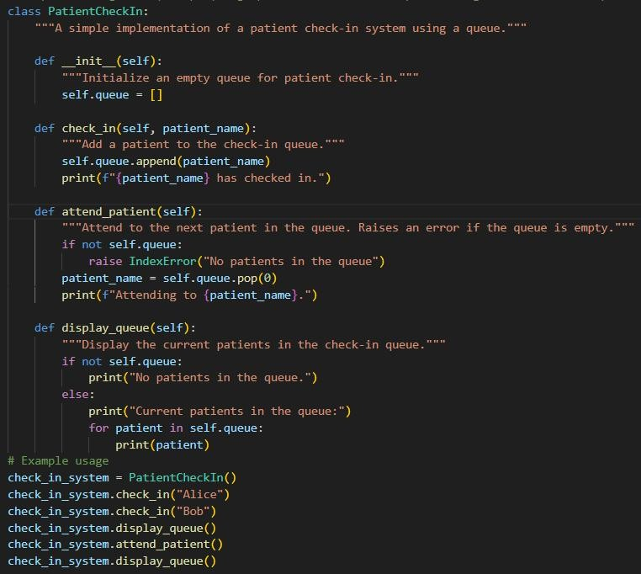
Output:-
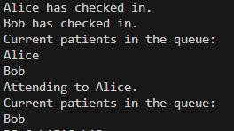
Justification:-
A queue is suitable for patient check-in as it ensures that patients are attended to in the order they arrive, providing a fair and organized system for managing patient flow. This structure allows for efficient handling of patient check-ins and ensures that no patient is overlooked or attended to out of turn.
Task Description #7: Smart City Traffic Control System
A city plans a Smart Traffic Management System that includes:
- Traffic Signal Queue – Vehicles waiting at signals.
- Emergency Vehicle Priority Handling – Ambulances and fire trucks prioritized.
- Vehicle Registration Lookup – Instant access to vehicle details.
- Road Network Mapping – Roads and intersections connected logically.
- Parking Slot Availability – Track available and occupied slots.
Student Task
• For each feature, select the most appropriate data structure from the list below:
- Stack o Queue o Priority Queue o Linked List o Binary Search Tree (BST)
- Graph o Hash Table o Deque
- Justify your choice in 2–3 sentences per feature.
- Implement one selected feature as a working Python program with AI-assisted code generation.
Expected Output:
- A table mapping feature → chosen data structure → justification. • A functional Python program implementing the chosen feature with comments and docstrings.
Prompt:write a python program to implement a smart city traffic management system. using queue
for vechicle wait in traffic signal, priority queue for emergency vehicles, graph for city road network, and hash table for vehicle registration. Briefly explain why each data structure is suitable for its respective feature in 2–3 sentences each. '''
Explanation:-
Feature | Data Structure | Explanation
Vehicle Wait in Traffic Signal | Queue | A queue is suitable for managing vehicle wait times at traffic signals as it follows the First-In-First-Out (FIFO) principle, ensuring that vehicles are processed in the order they arrive at the signal.
Emergency Vehicles | Priority Queue | A priority queue is ideal for managing emergency vehicles as it allows for the prioritization of vehicles based on their urgency, ensuring that emergency vehicles can pass through traffic signals without delay.
City Road Network | Graph | A graph is suitable for representing the city road network as it can model intersections (vertices) and roads (edges), allowing for efficient route finding and traffic flow management.
Vehicle Registration | Hash Table | A hash table is efficient for vehicle registration as it allows for fast retrieval of vehicle information using unique keys (e.g., license plate number).
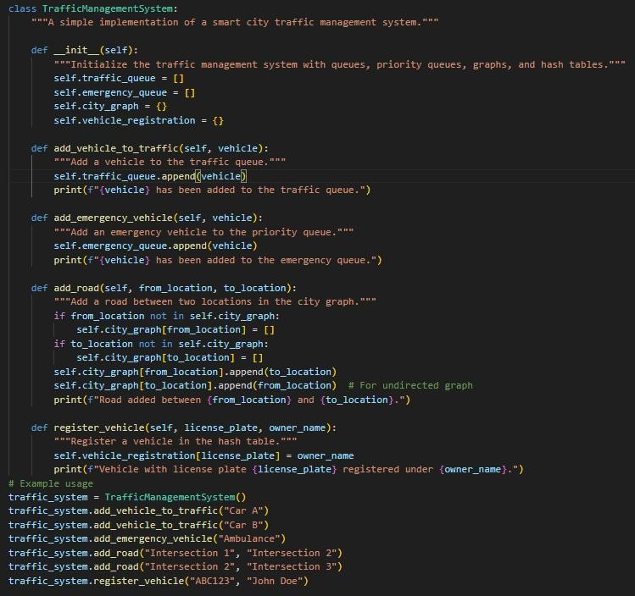
Output:-
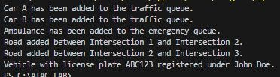
Justification:-
A queue is used for managing vehicle wait times at traffic signals to ensure that vehicles are processed in the order they arrive, while a priority queue is used for emergency vehicles to allow for prioritization based on urgency. A graph is suitable for representing the city road network as it can model intersections and roads, allowing for efficient route finding. A hash table is efficient for vehicle registration as it allows for fast retrieval of vehicle information using unique keys like license plate numbers.
Task Description #8: Smart E-Commerce Platform – Data Structure Challenge
An e-commerce company wants to build a Smart Online Shopping System with:
- Shopping Cart Management – Add and remove products dynamically.
- Order Processing System – Orders processed in the order they are placed.
- Top-Selling Products Tracker – Products ranked by sales count.
- Product Search Engine – Fast lookup of products using product ID.
- Delivery Route Planning – Connect warehouses and delivery locations.
Student Task
• For each feature, select the most appropriate data structure from the list below: o Stack o Queue o Priority Queue o Linked List o Binary Search Tree (BST)
o Graph o Hash Table o Deque
- Justify your choice in 2–3 sentences per feature.
- Implement one selected feature as a working Python program with AI-assisted code generation.
Expected Output:
- A table mapping feature → chosen data structure → justification.
- A functional Python program implementing the chosen feature with comments and docstrings.
Prompt:write a python program to implement a smart E-commerce platform. add and remove products dynamically using a linked list, order processing order they were placed using a queue, manage customer reviews using a hash table, and recommend products based on user preferences using a graph. Briefly explain why each data structure is suitable for its respective feature in 2–3 sentences each.
Explanation:-
Feature | Data Structure | Explanation
Add and Remove Products | Linked List | A linked list is suitable for managing products as it allows for dynamic insertion and deletion of products without the need for contiguous memory allocation, making it efficient for a growing product catalog.
Order Processing | Queue | A queue is ideal for processing orders in the order they were placed, following the First-In-First-Out (FIFO) principle, ensuring that customers receive their orders in a timely manner.
Customer Reviews | Hash Table | A hash table is efficient for managing customer reviews as it allows for fast retrieval of reviews using unique keys (e.g., product ID), enabling quick access to feedback for each product.
Product Recommendations | Graph | A graph is suitable for recommending products based on user preferences as it can model relationships between products (vertices) and user interactions (edges), allowing for personalized recommendations based on similar products or user behavior.
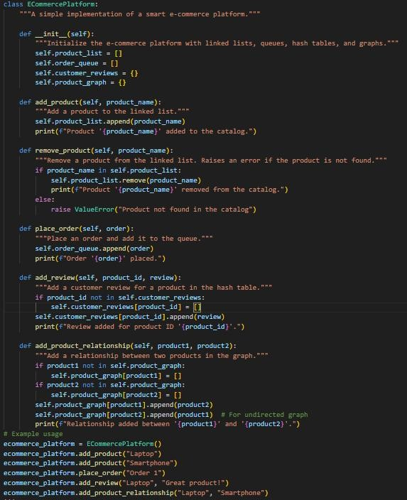
Output:-
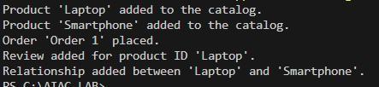
Justification:-
A queue is suitable for patient check-in as it ensures that patients are attended to in the order they arrive, providing a fair and organized system for managing patient flow. This structure allows for efficient handling of patient check-ins and ensures that no patient is overlooked or attended to out of turn.

